

Welcome to the 11th Edinburgh North East Scouts -

Broughton St. Mary’s

Useful Information for Scouts and Parents

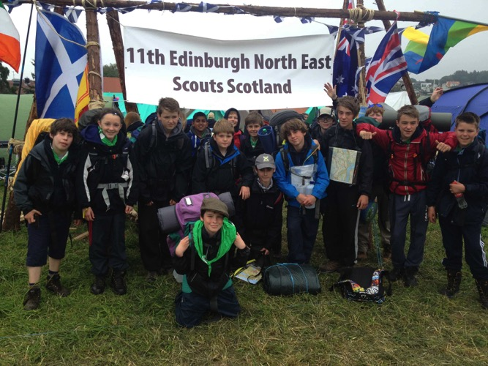

Version 1.3: 15/01/2015

Contents

1. What is Scouting?
2. Meetings; timing, terms
3. The Programme
4. Who are the leaders?
5. A typical Troop Night
6. Uniform & Badges
7. How much does it cost?
8. Where to buy ‘stuff’
9. Investiture
10. Attendance
11. Parent Power
12. Useful Reading
13. Glossary

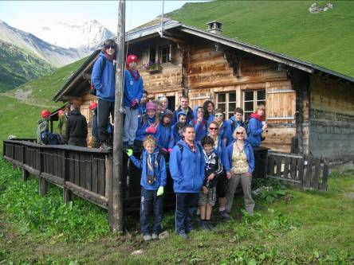

7,500 feet up a Swiss mountain

1. What is Scouting?

Scouting is a worldwide youth movement of 28 million members with the aim of supporting young people in their physical, mental and spiritual development, preparing them to lead constructive lives and be good citizens.

Scouting began in 1907 when Robert Baden-Powell, Lieutenant General in the British Army, held the first Scout camp at Brownsea Island in Dorset. Baden-Powell wrote the principles of Scouting in his book, ‘Scouting for Boys’, published in 1908. Since then, Scouting has evolved to provide informal education for girls and boys with an emphasis on practical outdoor activities, such as camping, woodcraft, aquatics, hiking, backpacking, and other sports. A widely recognised characteristic is the Scout uniform, which was intended to hide differences in social standing and emphasise equality. These days it’s also a useful place to hang badges! There are still some ceremonial vestiges left-over from our military roots, but these are aimed at developing mutual trust and respect and aren’t intended to be drill practice…..we leave that to the army cadets, who do it much better and seem to enjoy it more.

The 11th Edinburgh North East (ENE) Broughton St Mary’s Scout Troop have been meeting in the Broughton area of Edinburgh for more 90 years and hold their weekly troop meeting in Broughton Primary School Hall on McDonald Road.

1. Meetings; timing, terms

On a regular troop meeting night Scouts should assemble in the gym hall of Broughton Primary School on McDonald Road (see map) in time for a

**7.15pm Flag Break (aim for a 7.10pm drop-off). Flag Down is 8.50pm (collection is 8.55pm)**

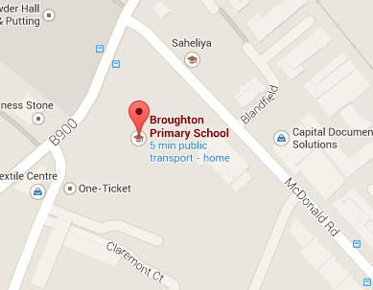

Try to be on time for collection but if you are going to be late, please phone on mobile number 07429 452 449.

As we meet in a school and not our own Scout Hall, we are influenced by Edinburgh Council letting arrangements and closely follow school term arrangements. Generally, we run three terms; Term 1 (Autumn) runs from September to December with a break for two weeks in October for the school holidays. Term 2 (Winter) runs from January to March (with a break in February for the mid-term holidays) and finally Term 3 (Spring) runs from April to June with no breaks. See specific details in the Programme section of the website, http://11thbroughton.scoutsites.org.uk.

1. The Programme

Our programme follows the current Scout challenge structure, which consists of six ‘basic skills and general interest’ challenge badges:

* Community
* Fitness
* Creativity
* Global
* Promise
* Outdoor

and two from three specialist badges:

* Outdoor Plus
* Adventure
* Expedition

Success in these challenge badges, which take around 3.5 years to earn, can result in the award of the prestigious Chief Scout Gold Award.

In addition there are loads of individual interest badges, known as Activity badges, for your Scout to earn. Sewing on badges is a useful skill, but be aware they’ve invented Badge Glue to help with that process now. Ask a leader or google **Loctite 595 Superflex Clear,** for details.

A copy of the current programme is circulated by e-mail at the beginning of each term and displayed on our website http://11thbroughton.scoutsites.org.uk. If this all seems more bewildering than the Curriculum for Excellence, don’t worry, just pop into the hall after Scouts one night and one of the leaders will talk you through it.

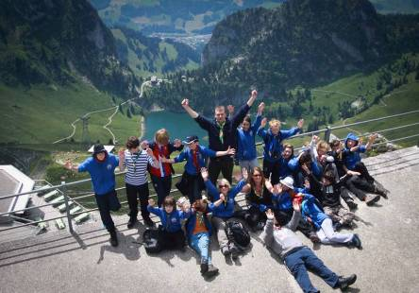

The 11th in Switzerland, 2011

1. Who are the Leaders?

We are very lucky to have a healthy number of leaders in the group with a wide range of backgrounds and skills. The troop leaders are a mix of parents of children in the group, parents of ex-members and young people who’ve come-up through the movement with a fantastic range of experience in Scouting. Some leaders have a spiritual faith and some don’t, but we all agree on a desire to complement your own family beliefs and to teach tolerance and respect for all.

**Scott Richards** is Scout Leader. He has lived in Edinburgh for 18 years and has one son in the Scouts. He has been involved in Scouting since 1987. He is married to Nancy, a leader in the Beaver Scout section.



Tel: 01315578879, 07429452449, [11thenescouts@gmail.com](mailto:scobesfoto@gmail.com)

Dave Anderson is an Assistant Leader and the elder statesman of the troop. He has given decades of dedicated service and is a former Scout of this troop himself. He is a Broughton man, born and bred. His son Colin is a former leader in the troop and Dave is a busy grandfather of two.

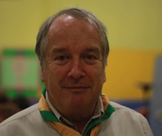

Tel:01315525254, 07976248418, [david@anderson.cx](mailto:david@anderson.cx)

Steve Irvine is an Assistant Leader who joined the troop after years of service as a section assistant in the cubs. Steve is also a Broughton man and has two children in Scouting.



Tel:01315564828, 07954141963, [steve.irvine56@sky.com](mailto:steve.irvine56@sky.com)

John Beaton is an Assistant Leader who joined the troop in January 2015 from the cub section. He hails from South Queensferry and despite his youthful appearance, has a long experience of Scouting with a particular interest in international camps.

Insert photo

Ola Walker is a Young Leader. She joined the troop at the age of 10 from the Brownies. Ola is a Leither of Polish/Canadian heritage and speaks fluent Polish.

Insert photo

Lachlan Morrison is also a Leither and continuing the international nature of our young team, he is of Scots/USA extraction. Lachlan regularly attends summer camps in the USA.

Insert photo

Leaders are fully PVG disclosed, hold the highest Scout Award for leader training and undertake regular Health & Safety, First Response and Child Protection training as a minimum.

1. A typical Troop Night

On a troop night in the school gym hall, we always aim to start at 7.15pm unless we notify you of any changes in advance. If we are meeting for an outdoor activity on a troop night, it will generally be 6pm in order to make best use of available light. Weekend activity start times will vary depending on the precise arrangements. Refer to the online programme for details.

A typical troop night will consist of this pattern

**7.10pm** Assemble

**7:15pm** Flag Break –Scouts form-up into their patrols and we salute the flag

**7.30pm** A warm-up game

**7:50pm** Badge Work & Tuck Shop

**8.20pm** Another game

**8.40pm** Notices

**8.45pm** Flag Down – A ceremony where the flag is lowered

**8.50pm** Home time

1. Uniform and Badges

Scouts love gaining badges and displaying them for everyone to see on their uniform. As we’ve covered already, there are Challenge Badges (diamond shaped ones) and Activity Badges (circular) but there are also badges to show which country, region, district and troop your Scout is from. There are badges to show their patrol name and their status, e.g. Patrol Leader or Assistant Patrol Leader and there is the World Scout Badge (the fleur-de-lis). Try to sew or stick them on as soon as possible after your Scout gains them, to encourage them to aim for more. Better still; teach them to sew their own. I find sticking with badge glue and then four little stitches at opposite sides of the badge makes for a good long-term fixing. You can buy badge glue by *Googling* **Loctite 595 Superflex Clear**. You’ll find it on eBay for a few pounds.

Knowing where to attach badges isn’t easy and Scouts will want you to get it right, so on the next page we’ve outlined the uniform generic guide and some images of an 11th Troop uniform:

In addition, once a Scout is invested they wear a neatly rolled triangular neckerchief around their neck and the two ends are held together with a ‘woggle’. The colour scheme signifies the troop. The 11th ENE neckie is Gold and Green and can be bought from the Scout Leader for £5 or from The Edinburgh Guide shop for the same price.

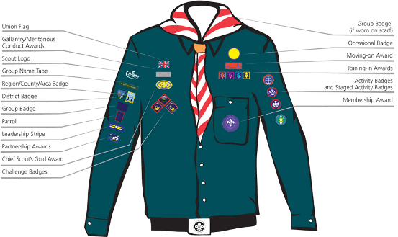

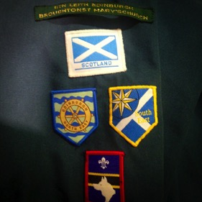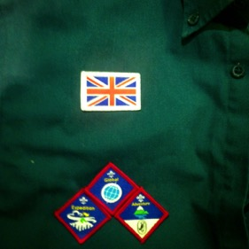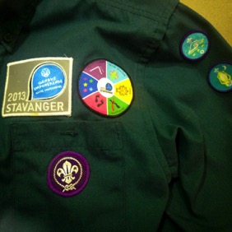

Right Sleeve Right Breast Left Breast & Sleeve

1. How much does it cost?

Subscriptions are £15 per term, so a full year costs £45. We ask that you pay in instalments of £15 at the beginning of each term and we’ll send a reminder home with Scouts. Please pay promptly by cash or cheque; cheques should be made payable to 11th ENE Scout Group and cash in a sealed envelope with your Scout’s name on the front should be handed to the duty Scouter. New Scouts don’t need to pay until they have been invested.

Leaders are unpaid volunteers in Scouting, but there is a small, paid staff at HQ to administer and develop the movement. Some of the subscription monies go to pay their salaries. Other elements of subs pay for equipment and replacements, hall hire and indemnity insurance. You’ll find that we will ask you to contribute to activities which take place outside the Scout Hall, e.g. transport costs and camping costs, but we try to keep these to an absolute minimum, and apply for grants and perform fund raising to off-set costs. You can expect to be asked for a contribution toward one camp per term (approx £25) and some sundries. This might seem rather a lot, but when at camp, we are typically paying for accommodation, food, transport and activity costs. Where else could you spend a weekend away from home for under £30 all-in?

1. Where to buy ‘stuff’?

There is no Scout Shop in Edinburgh, but the Guide Shop in Edinburgh keeps a modest stock of Scout Shirts, woggles and other ‘stuff’. You can find them at 16 Coates Crescent, Edinburgh, EH3 7AH (0131 225 3483)

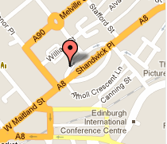

There is an excellent Scout Shop in the west end of Glasgow, or you can order on-line from <http://www.scoutshops.com/>. We’ve also seen Scout shirts being sold in Clan House at Grove Street.

As Scouts get into the outdoor life, they’ll need sturdy boots and waterproof gear, and these can be bought locally from shops like Leith Army Store, Tiso, Go Outdoors, etc. You can also order online from your preferred suppliers.

1. Investiture

Scouting isn’t for everyone and with so many other spare-time opportunities available to teenagers now, we think it’s prudent to let your Scout give it a try and then decide if Scouting is for them. I’m glad to say that most do, but whilst they are settling-in, we hold-off investing them into the Scouts until we feel they are ready. Typically this is about 4-6 weeks after joining and we will give you a date for investiture shortly after your Scout joins.

The ceremony of investiture is where a new Scout will make the **Scout Promise**, having spent some time talking about what it means to be a Scout with a leader and other new Scouts. During a short ceremony, we ask Scouts to make a promise. Scouting in the UK is open to people of all nations, faiths, and beliefs and the Scout Promise can be adjusted to accommodate all. Please let us know in advance if you would like your young person to vary from the standard **Scout Promise**, which is:

On my honour, I promise that I will do my best,

To do my duty to God and to the Queen,

To help other people,

And to keep the Scout Law.

Scouts will also be taught about the **Scout Law**, which is

* A Scout is to be trusted.
* A Scout is loyal.
* A Scout is friendly and considerate.
* A Scout belongs to the worldwide family of Scouts.
* A Scout has courage in all difficulties.
* A Scout makes good use of time and is careful of possessions and property.
* A Scout has self-respect and respect for others.

Finally, we will introduce the **Scout Motto**:

* Be Prepared

Dyb dyb dyb, dob dob dob has not been used in the Scout movement since the 1950s. Out of interest, it was a greeting between the leader and Scouts which stood for **D**o **Y**our **B**est (DYB) answered by **D**o **O**ur **B**est (DOB). Although no-one uses it in Scouting anymore, it’s popularity has endured

Scouts shake hands with their left hand (not the customary right hand), which causes no-end of confusion for new Scouts.

1. Attendance

Regular attendance is important because we work to a programme throughout each term. If your Scout misses meetings, they’ll fall behind and struggle to catch-up with the main body. However, Scouting is meant to be **FUN**, so if you anticipate a period of extended absence, let us know and we’ll make arrangements.

If you and your Scout decide that Scouting isn’t for them anymore, please drop Scott a note or give him a call. A percentage of young people find other things to do with their time before they are due to graduate to Explorers and that’s fine. It helps us if we know if a Scout has reached that point and we won’t try to apply pressure to stay. That’s a decision between parent and Scout.

1. Parent Power

If you have any skills or interests that you feel could enrich our programme, e.g. are you a kayak instructor, or tie an amazing knot, please let us know. We promise not to try to press-gang you into the movement, but it can only improve the programme to have access to people with specific skills willing to give-up a little of their time to share it.

Also, if you are interested in coming along to help out, let us know and we’ll book you in. You’re very welcome to come along and see what happens. We have parents who help out at camp but at no other time, their assistance is essential to the smooth running of a camp.

1. Useful Reading

You’ll find loads of useful information about Scouting and the outdoors in Libraries, book shops, the Guide Shop and on-line. The Scout Association website is chock-full of information and has a special section for parents

<https://members.scouts.org.uk/cms.php?pageid=1816>

Our own website has some useful information, so please subscribe to updates

<http://11thbroughton.scoutsites.org.uk>

You can find our camp blog at Polaroid Blipfoto.com, it’s active when we are camping for an extended period, e.g. summer camps.

<http://www.blipfoto.com/persevere>

1. Glossary

The Scouts have a language of their own, much of seems to be designed for comic effect. Here are some of the more obscure

**Activity Badge** – A specific interest badge awarded to Scouts for interests outside the main programme. Round badges worn on the left sleeve

**Action song** – A campfire song with has associated body movements.

**Auchengillan** – The camp-site of the Glasgow Scouts, regularly used by the 11th ENE Troop.

**Assistant Patrol Leader** - A Scout who helps the Patrol Leader and takes over in their absence.

**Baden-Powell** - Lord Robert Stevenson Smyth Baden-Powell, the founder of world Scouting.

**Beaver Scout** - A youth member of the Beaver section, usually 6-8 years of age

**Bivvy –** A temporary shelter in which to sleep; sometimes made from a manufactured bivvy bag, or from natural materials found whilst hiking.

**Bonaly** – The Edinburgh Scouts camp-site in the Pentland Hills, near Colinton

**Breaking the flag** - Causing a flag to fly free from the bundle in which it was tied. Normally done with the national flag at the opening of a troop night

**Campfire** - A gathering of Scouts, usually around a fire, to have fun by singing, acting, telling jokes, and hearing stories.

**Campfire blanket** - A simple blanket worn or wrapped around oneself at campfires. Some Scouts sew badges on their campfire blanket.

**Challenge Badge** - Any of the diamond badges that a Scout may earn as part of the programme. Worn on right breast of uniform.

**Chief Scout's Gold Award** - The highest award in the Scottish Scouts

**Chief Commissioner for Scotland** – The Chief Scout’s representative in Scotland.

**Cub Scout** – A member of the Cub Scout section, usually 8-10.5 years of age.

**Executive Committee** – Unpaid volunteers who support the section leaders to run the Group. Typically consists of ex-Scouters and parents

**Fordell Firs** – The HQ of Scottish Scouting and a popular camp-site

**Gilwell Park** - The international training centre in England where the very first training courses were held and the HQ of Scouting in the UK.

**Jamboree/Jamborette** - A large gathering/camp of Scouts from around the world.

**Kandersteg** – The permanent Jamboree site in Switzerland recently visited by the 11th ENE.

**Knife** - Used by Scouts under strictly controlled conditions. Knife law in Scotland prohibits the general carrying of knives.

**Leader** – A Scout Leader or Assistant Leader who has a warrant

**Lowering the flag/flag down** - Lowering of the flag by a Patrol Leader to mark the end of the meeting

**Necker/neckie** – The triangular neckerchief worn around the neck and held together with a woggle. The colour scheme signifies the troop. The 11th ENE neckie is Gold and Green and can be bought from the Scout Leader for £5

**Night hike** - A supervised hike, which happens during the night and has a period of sleeping in a sleeping bag or bivvy.

**Patrol** - A small group of Scouts of mixed ages, typically consisting 6 Scouts. A Scout Troop is made up of several patrols.

**Patrol Leader** - The member of a Patrol who is responsible for leading the patrol.

**Programme** - The plan of activities undertaken by a section.

**Promise** - A series of words said by a member to affirm dedication to the

**Scout Group** - Several associated sections, e.g. Beaver Scouts, Cub Scouts, Scouts and sometimes Explorer Scouts

**Scouter** - Adult members of Scouting who operate a Scouting programme or support other Scouters.

Section - The group of youth members and their Scouters that meet together on a regular basis, e.g. Beaver Colony

**Troop** - The name for a section of Scouts; a Scout Troop.

**Troop Night** - The weekly gathering of a Scout Troop.

**Uniform** - The green shirt and neckie that a Scout wears while participating in Scouting activities.

**Woggle** - A tube through which both ends of a rolled neckerchief are passed so that it can be worn around the neck. Any material can be used to hold a neckerchief in place, but typically made from leather or plastic

**Wood badge** - The system of Scouter training, which is externally accredited.

**World Organization of the Scout Movement** - The organization responsible for coordinating the Scout Movement worldwide.

Version

|  |  |  |
| --- | --- | --- |
| No | Date | Reason for Issue |
| 1.0 | 08/09/2011 | First issue |
| 1.1 | 10/09/2011 | Correcting typos and factual errors |
| 1.2 | 10/09/2013 | Brought up to date |
| 1.3 | 15/01/2015 | Brought up to date |